***Make this shorter for 1 lesson next year***

|  |  |  |  |  |  |
| --- | --- | --- | --- | --- | --- |
| Unit 2  Mathematics Methods  Investigation #4  Differentiation  In-Class   |  |  | | --- | --- | | **Name** |  |   **Important Information:**  *Although the take-home component is not worth any marks, it is essential in preparation for the in-class component. Knowledge and skills gained will be extended in the in-class validation component. This in-class validation will be completed under test conditions on the day in which this take-home component is due. The take-home component may be used when completing the in-class component.* | | | |
| **Take home component weighting:** | *0% of the year* | **In-class component weighting:** | *5 % of the year.* |

***You may use your out of class section as notes for this test. CAS calculator permitted.***

**Part A**

When travelling by air, some destinations specify luggage limitations in linear measurements rather than weight. This is defined as

*linear measurement* = *width + height + length.*

For one airline the maximum linear measurement is 158 cm for any one piece of luggage. All the shapes considered in Part A have the maximum linear measurement and are to be investigated for their maximum volume.

**Question 1 (12 marks)**

Luggage item is the shape of a rectangular prism

*The length (l) of this item is twice the width (w) of the item.*

(a) State the rule to calculate the volume (*V*) of the item. (1)

(b) Show how you can determine that for the height (*h*),  (2)

(c) Write the rule to calculate the volume in terms of *w* only. (1)

(d) Determine  (2)

(e) For what value of *w* is the volume a maximum? (Use calculus) (2)

(f) Determine the maximum volume. (2)

(g) When the volume is a maximum, (2)

(i) what is the length?

(ii) what is the height?

**Question 2 (7 marks)**

Luggage item is the shape of a triangular prism

*The length (l) of this item is twice the width (w) of the item.*

(a) Given , the rule to calculate the volume (*V*) of the item, determine  . (2)

(b) Use the expression for , identified in part (a) to determine the value of *w* for which the volume is a maximum. (2)

(c) Calculate the maximum volume. (1)

(d) When the volume is a maximum, (2)

(i) what is the length?

(ii) what is the height? (Use the linearity condition from PART A)

**Question 3 (9 marks)**

Luggage item is the shape of a cylinder

Remember Volume = x length

(a) Show that the volume of the cylinder is given by the rule  (3)

(b) Use calculus techniques to show that a maximum volume occurs when the radius *(r*) is  cm (3)

(c) Determine (3)

(i) the maximum volume of the cylinder

(ii) the length of the cylinder when the volume is at a maximum.

**Question 4 (11 marks)**

Luggage item is the shape of a hexagonal prism; the base is a regular hexagon.

The width and length are equal and they are each double the length of the congruent sides of the hexagon.

(a) The rule for calculating the volume of this hexagonal

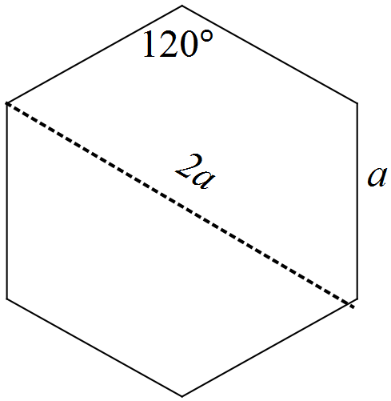 prism is  .

Explain how this rule can be written as

 (3)

(b) Use calculus techniques to determine the value of *a* for which this prism has a maximum volume. (4)

(c) Determine (4)

(i) the maximum volume

(ii) the dimensions of the prism for which the volume is maximised.

**Part B**

**Question 1 (5 marks)**

In Part A, differentiation has been used to identify the dimensions for which the volume of a 3-dimensional shape can be maximised.

(a) Describe how technology can be used to identify a maximum value for volume without differentiating the function. (2)

(b) What does the derivative of the volume function represent? (2)

(c) Why is the derivative of the volume function equal to zero when the volume reaches its maximum value? (1)

**Question 2 (6 marks)**

(a) Enter your results for the items of luggage in the table below. (1)

|  |  |  |  |  |
| --- | --- | --- | --- | --- |
| Shape | Maximum volume  (cm3) | Dimensions for maximum volume  (cm) | | |
|  |  | length | width | height |
| Rectangular prism |  |  |  |  |
| Triangular prism |  |  |  |  |
| Cylinder |  |  |  |  |
| Hexagonal prism |  |  |  |  |

(b) Rank the items of luggage in order of increasing volume. Comment on your listing. (1)

(c) What aspects of the dimensions of luggage items appear to produce shapes with maximum volumes? (2)

(d) One passenger had an item of luggage that satisfied the rule for maximum linear dimensions but its volume exceeded all of those listed in the table. Suggest a possible shape and the dimensions for this item of luggage. Show that its volume is greater than those listed. (2)

End of Investigation